# **Team_44 SSR Project REPORT:**

* **Table of contents and objectives:**
* What Comes in your Mind when you hear about social media?
* Why do you need Awareness?
* Why do teens use social media?
* social media benefits
* Behavior in social media
* Why do behaviors in social media matter?
* different types of Behaviors in social media?
* social media problems or disadvantages
* social media security
* social media addiction
* social media rehabilitation
* cybercrime examples in social media
* how to come out of it when you are trapped in social media?

# Acknowledgements:

All people want to be acknowledged. When it

comes to acknowledgement through social media, people want others to recognize that they are thinking and acting in a cutting-edge manner.It is critical that you acknowledge each and every person with whom you have a connection through social media.

Because it is still in its infancy, people don’t fully understand social media’s capabilities yet. You might ask, from a psychological perspective, what people are looking for in social media.

# SSR at Amrita University an Overview :

As part of the SSR (Student Social Responsibility) project, the students of Amrita University, Amritapuri Campus, visit villages across India, orphanages, schools etc.

The students get a rare opportunity to stand up for the society, think about their problems and finally come up with a solution.

# Team:

Team: SSR 21-22_44

Scrum Master: Abhinay_19311 Mentor: Ms. Indira

Coordinators and Documentations: Jagadesh_19339, Bhargav_19324 Webinars: P Teja_19341

Maintaining Quizzes, forms: Gnaneswar_19230, Bharath_19213 PPT and Reports: Phani_19311 Along Teja.

# Project:

Social media awareness

Research being presented finds that for 9- and 10-year-old children taking part in a study of brain development, greater social media use, such as scrolling through Instagram and texting, was associated with some positive effects, including increased physical activity, less family conflict and fewer sleep

# Background of the Problem:

The more time spent on social media

can lead to cyberbullying, social anxiety, depression, and exposure to content that is not age appropriate. Social Media is addictive. When you're playing a game or accomplishing a task, you seek to do it as well as you can.

# Addiction:

Excessive use of social media after a certain stage will lead to addiction. Eventually the addiction level may reach a point where it causes distraction from studies. After starting use of social media, many students are unable to focus their attention during lessons. The students are wasting time scrolling their newsfeeds and publishing posts.

# Socialization:

While it is true that social media helps to build distant friendships, the same could negatively impact the relationships of their close ones. Students who use social media excessively may lose relationships with their beloved persons. They might be highly addicted to social media such that they forgot to spend time with their friends and family.

# Cyberbullying:

As social media lets people be anonymous, it could be used as a platform for cyberbullying. Attackers tend to create fake accounts in social media so that they can tease and hurt other people.

Students, particularly teenagers are often targeted by the bully through hurtful messages. Often due to this, the students could face anxiety, depression, stress and other mental problems.

# Inappropriate Content:

Not all the contents available on social media may be appropriate for students. Students, especially underage children are exposed to inappropriate content both intentionally or unintentionally. This includes pornography as well. All of a sudden it can be shown while playing a game or scrolling a newsfeed.

Eventually the students might get mentally disturbed. It is the responsibility of the parents to monitor how their child is using social media.

# Health Concerns:

Most social media users including students often face many health problems due to excessive use of social media. Students who are addicted to social media spend day and night sitting in front of a computer or holding a smartphone. Since it does not involve much physical movement, the result of this can be obesity.

Even some students sacrifice their sleep for using social media. This can bring many sleeping disorders that can lead to other dangerous consequences.

Share This

# Activities undertaken :

1)We distributed the booklet for students under the age of 18. 2)We explained them with some examples

1. We still connected with those students who participated and helped them a lot after the session as well.
2. we published our session details in the newspaper in order to get more students or teens in our meeting

# Achievements:

1. participated students now well-known and has good awareness about social media
2. These students now know the benefits of social media. 3)They know how to handle unknown messages from strangers. 5)they are aware not to participate in spam links like lucky draw

6)they know how to handle wrong forwarded messages in whats app .7)Students are aware of the trolls in social media

1. we still connected with those students who participated

# Challenges Faced:

1. In this covid time it is very difficult to distribute the booklet to a lot of students.
2. To find a good mentor for social media awareness
3. To place the meeting which is convenient to all students.
4. some difficulty while taking session through online because of bad network

# The Road Ahead:

1. We are trying to do some real examples with students
2. We are trying to do some videos on you Tube to raise awareness among teens about social media
3. we are trying to distribute our booklet for social media awareness to the most of the students
4. we are trying to update our booklet every year with some new examples and publish again

# Image Gallery: 1.) Profiles:

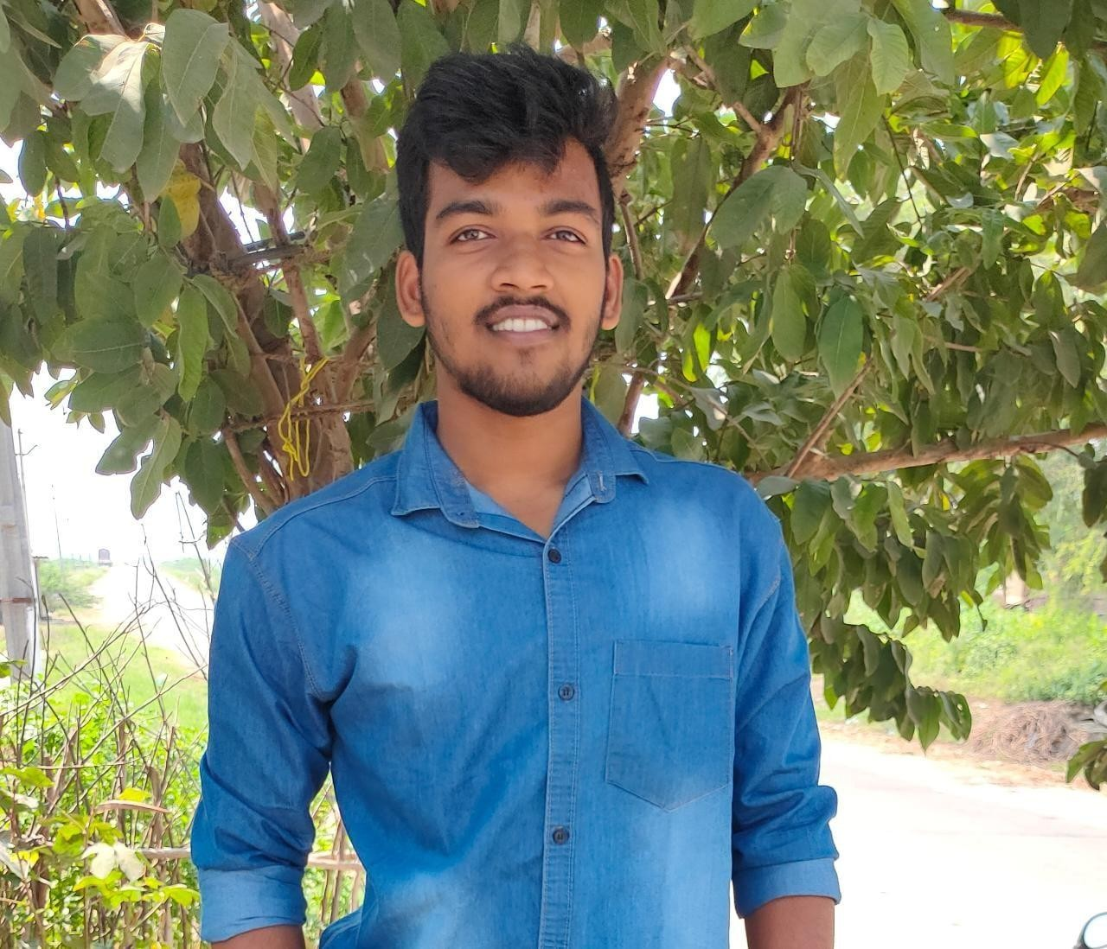 

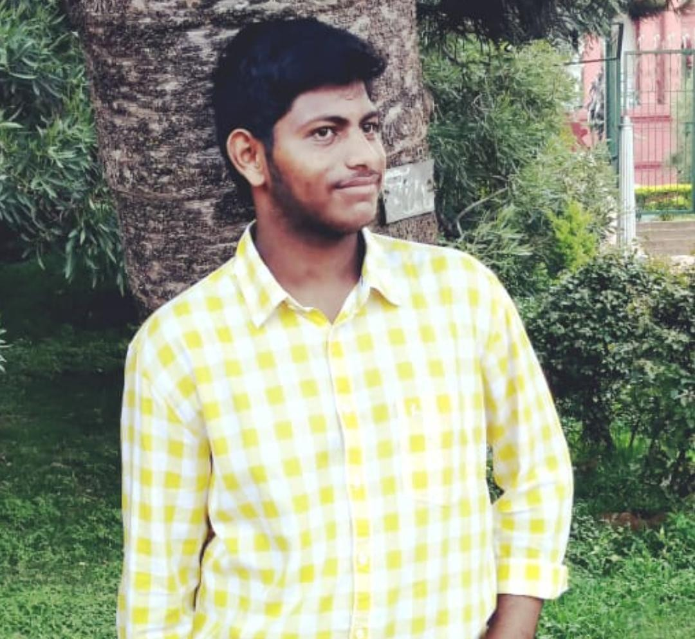

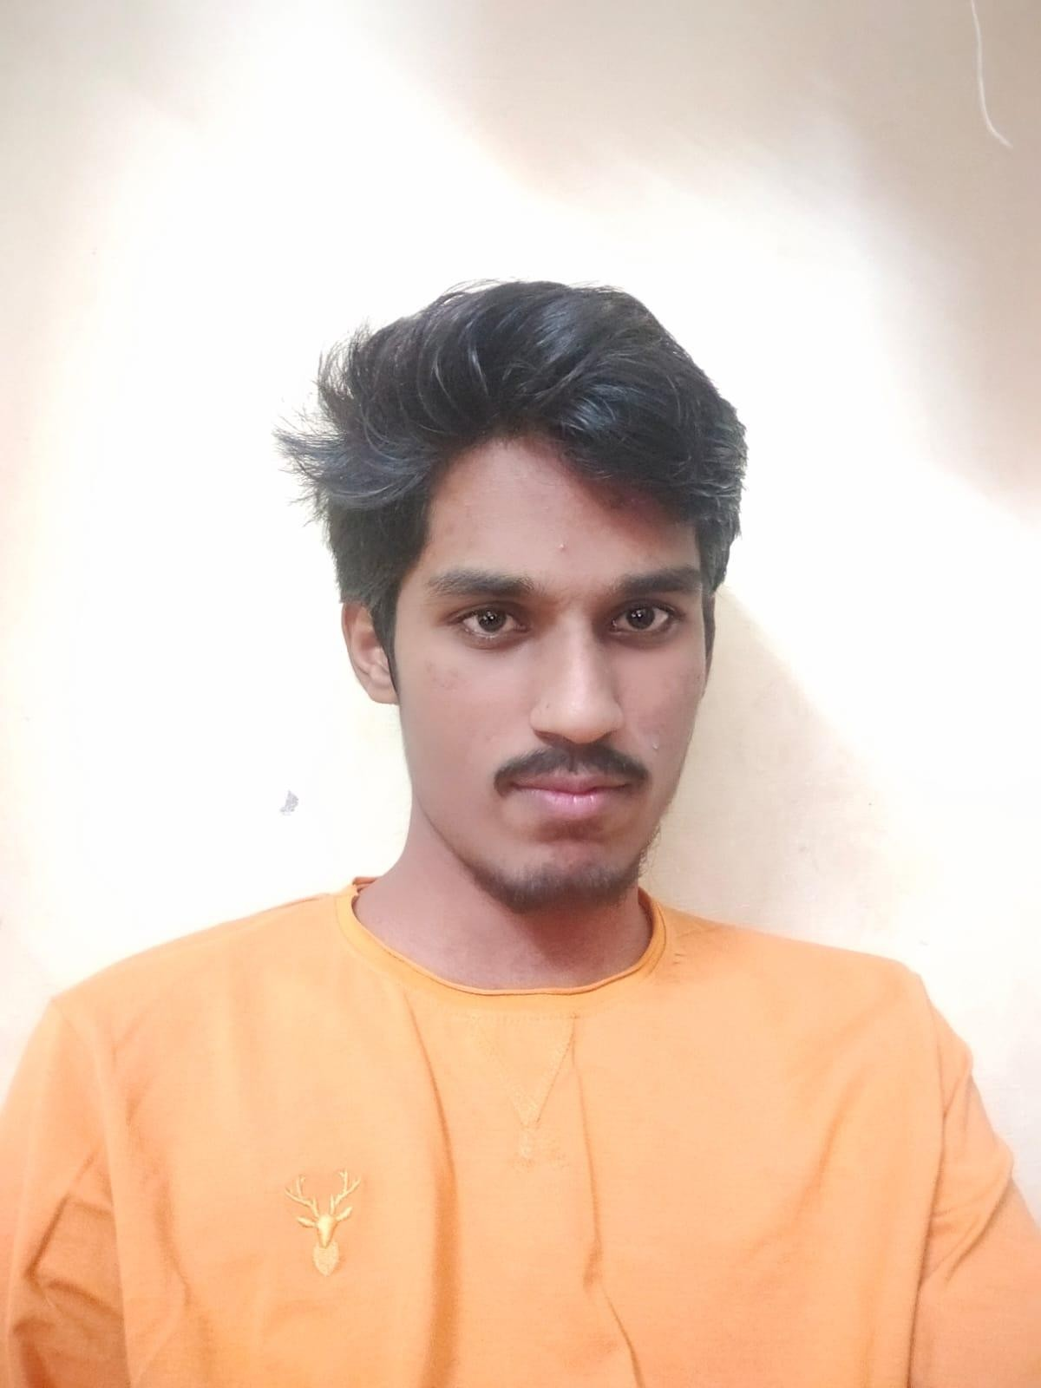

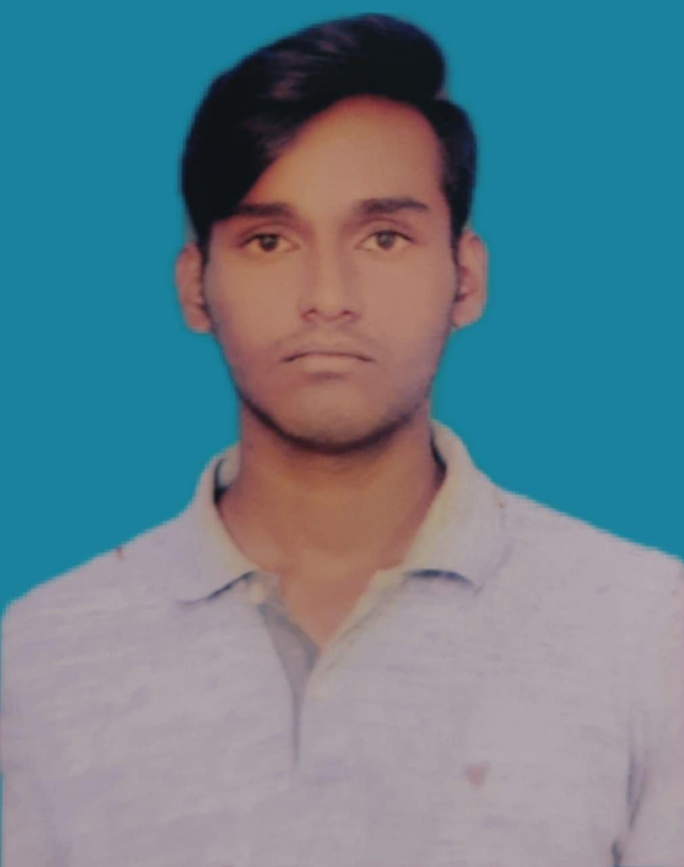

# 2.) Posters:

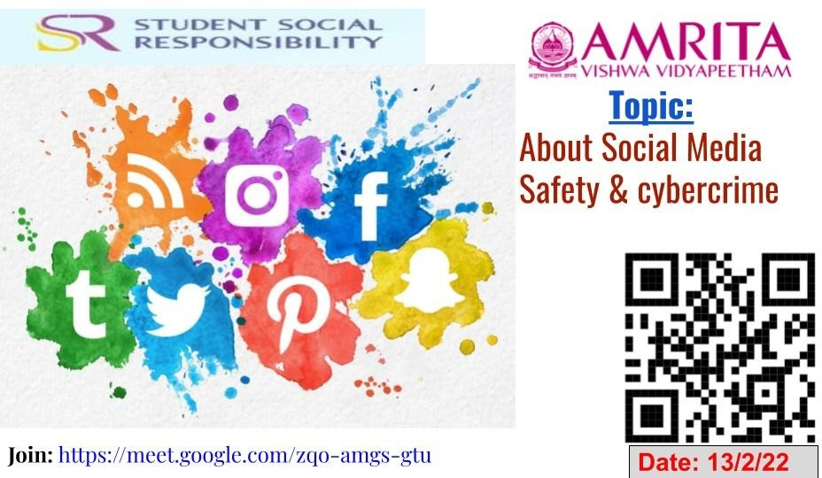

**3.) All Proofs(click links below):**

# Phase-1(documents, proposals)

* + - **phase-2(webinar recordings)**

# phase-3(feedback, Quizzes, final documentation)

★ **Team-44 work folder**

# ★ Short video

* + **Student Experiences 2-3 paragraphs (on the project for blog):**

Giving back to society whatever little we can, this is the small thought that led to this massive community service program that we call SSR (Student Social Responsibility). we need to try our best in doing good for others. We should be the reason to make the life of another unknown person better, or at least to bring a smile to others' faces.

The aim of this student driven program is nothing but the well-being of the society through various projects. Being able to interact with people and bring about solutions for the various problems in their daily life is something that the students of Amrita have mastered at this young age. The program teaches the students how to be socially responsible as citizens. The main idea, however, is to inspire - inspire the youth to take this up as an example and bring about a change in their own way!

We(students) get a rare opportunity to stand up for the society, think about their problems and finally come up with a solution. SSR projects are unique as in, they are done only in Amritapuri campus of Amrita University.

This project is mainly to ensure that every Amrita student does something for the society using their skills and knowledge to benefit the underprivileged or for the betterment of a greater, happier future.

# Note:

* **Click the links insert above at Image gallery part to see all our work OR:**

# To watch our short-video click Here.

* **To see Our Webinar Video Recording Click** [**Here**](https://drive.google.com/file/d/18-932f4NAsJv33WBQ1hGVH7VZ8iDZZoE/view?usp=sharing)**.**

# To View all our Project Work phases wises Click Here.